**REAL TIME WEATHER MONITORING SYSTEM INTEGRATED WITH API**

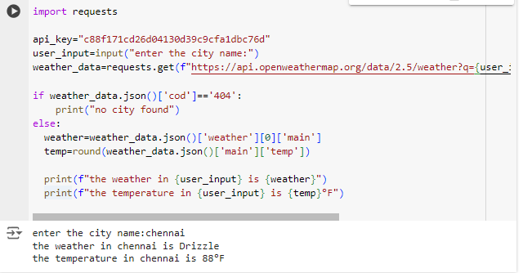

**Inventory Management System Optimization**

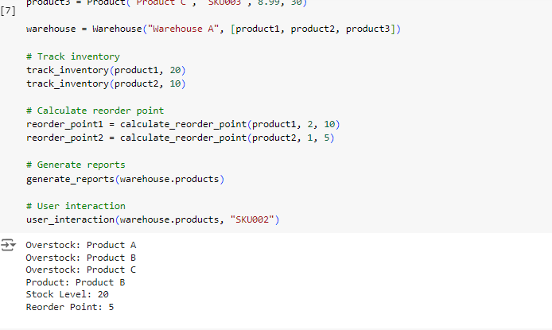

**Real-Time COVID-19 Statistics Tracker**

